**1 Introduction**

**VirueX- Planning, Development and Implementation of The Virtual Exercise System**

Rikesh Thapa *[CS(BS), FE(BA) '15]* , Cara Kessler *[CS(BS) '15]*, Charlie Henick *[FE (BA)'14]*, Adam Cushmaro *[CS(BA) '15]*, Christopher Wong *[CS(BA) '16]*, Lukas Slipski *[HBS, Take-5'14]*, Marquis Massie *[BCS(BS) '15]*

**Key:** CS: Computer Science; FE: Financial Economics; HBS: Health, Behavior and Society; BCS: Brain and Cognitive Sciences; '14'15'15: Class of 2014, 2015 and 2016 respectively.

**Abstract: --** In this paper we will describe the VirtueX project being embarked by our team Recycle. Our project has two major components: 1) External device implementation and data collection 2) Graphical display of processed data. 1)Device data collection will allows for the analysis of blood flow, blood pressure changes, pulse measure, perspiration, general movement and heat flow within the human body using various devices. This quantitative information is automatically passed into our mySQL implemented database where it stored and prepped ready for analysis. 2) The software component involves the processing and analysis of data collected in (1). We then proceed to make it understandable and readable though out graphical user interface that takes in our processed data in real time and reflects knowledge mined through frequent process mining techniques. That being the software hardware component design, the broader implication of our project involves the analysis of minor and major, obvious and subtle changes in the body of a user in order to analyze their movement technique, determine which areas of the body are undergoing tension, predict possible injury points, and make predictions on body changes (weight, percent fat, metabolic rate, BMI, etc) in near and far future. This paper will clearly define what Team Recycle is trying to solve with VirtueX and how we will go about solving it. Furthermore, we will go about listing our extensive equipment usage and how we plan on using each equipment along with any hardware adjustments and software modifications. Throughout this project we will be making extensive use of open source software, private software and self coded software-- in the end we do not want to recreate the wheel but instead dedicate as much of our time as we possibly can on developing VirtueX. Finally we will describe not only our design procedures, but also our need finding research and the numerous iterations that we will be going through in order to make sure that VirtueX is both functional and user friendly.

Injury prevention has been a hot topic in medicine, engineering, biology and other subject areas for many centuries [1]. Only since the 1950s has our understanding of injuries truly change. After Hug DeHaven's work began to illustrate that the distribution of energy forces could influence or affect the injury and it's severity, we began to understand that a major way to reduce injuries was through the process of changing our environment and in which way they took place [2]. The definition of injury arises from this work--"Injuries occur as the result of energy transfer the is delivered in excess of the threshold." [3] Major recent attempts at reducing injury has been implemented through by keeping this definition on mind, from placing cushions or soft foam in various area of impact in athletics, and various protective gear.

However, despite this understanding and new advances in biotechnology and medicine, there has been a rise in injury caused by, sports, physical activity, daily home activity and regular day to day actions (especially among the elderly).[4] The rise in injury of children during physical education classes has risen by 150% in the last 10 years while as a whole there has only been a slight increase in PE participation. [5]

There are two types of injuries: acute injury and overuse injury. When an individual sustains an injury as a result of concussion, or they break their collar bone, they suffer an acute injury-- i.e. an injury caused by a singular event such as a fall or a sudden trauma. On the other hand, overuse injuries develop slowly over time through the repetitive stress applied on tendons, muscles, bones or joints[6]. VirtueX attempts to target this particular type of injury-- overuse injury.

The fact of the matter is that overuse injuries are injuries are difficult to diagnose because the pain resulting from each micro trauma is unnoticed or is slighted during the initial progression of the injury because individually each injury does not affect function in the early stages.[6] Many have attempted to teach students, children, athletes, adults a the elderly to self diagnose when a micro trauma is occurring however this is simply an inefficient and ineffective task. The severity of the situation can be seen through the fact that every year 3.5 million children under the age 14 are treated for sports injuries, and among middle school and high school athletes, half of them are overuse injuries. [7] Furthermore, over the past 10 years there has been a fivefold increase in the number of severe elbow and shoulder injuries in youth baseball and softball players alone [8]

While a lot of emphasis has been placed on physical activity related injuries of the youth, "there is no question that the elderly... are more prone to a range of injuries." [10] Where there is a rise in injury the youth, there is a proportionate exponential rise in injury of adults and an even more exponential rise to the general elderly (50+) population due to unavoidable loss of bone (especially in women), decreased flexibility due to changes in the body's connective tissue resulting in joints having to bear greater stress [10].

Currently the only solution to this "epidemic"[6] is an attempt to teach individual to diagnose when they are being subject to micro trauma. However as we mentioned before, this is very inefficient, and the fact that individuals cannot feel a micro trauma clearly poses major limitations on this approach. However, in almost all movements, poor mechanics is the number one cause for overuse injury. Improper technique places unsafe torque and pressure on tendons, bones and joints.[6] VitueX attempts to exploit this cause to make an attempt at predicting trauma in the early stages.

The idea that Team Recycle is proposing aims to help chip away at this problem, while providing a spectrum of various other applications, in addition to injury prevention.

Throughout our body, our heart beats and supplies blood to all the organs of our body at a certain rate per second. The pulse is an indicator of heat rate. As we exercise our pulse rate increases. An example of this is a dimensional motion exercise, such as a bicep curl. When one performs a bicep curl, the only muscles one would like to apply tension to are the biceps. In figure 1, we can see the targeted muscles highlighted in red. The activated muscles (relative to the rest of the body) will experience increased blood flow, a peak in the pulse rate, increased perspiration to the surface of the skin, thousands of electrical nerve impulses directed in the direction of the biceps, and increased heat flow.

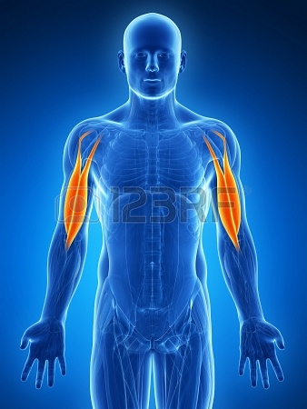

*Figure 1: Bicep Activation*

It is our belief that we can exploit these changes in bodily functions and physical state to tackle a few big topics which have to do with musculo-skeletal movement:

1. When performing a static exercise, such as a bicep curl, we often do not know simply through observation via naked eye whether or not we are performing the exercise correctly i.e. technique--more aptly, stimulating the intended muscles.
2. When performing dynamic movements such as running we are unable to identify whether or not the individual is performing the correct technique so as to maximize performance (in the case of competitive running) or preventing unnecessary tension in the knees, ankles and hips (as in the case of an average runner) [11] 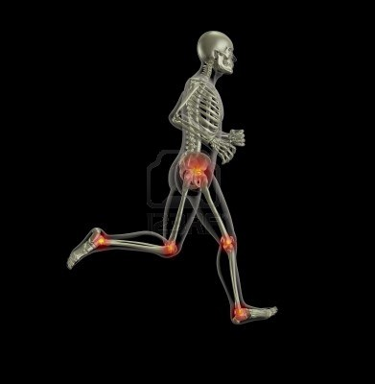

3. In the case of physical rehabilitation, predominantly for the elderly, we would want to prevent tension in the lower back, for example, by providing the right type of support through proper shoes or walking sticks, etc.

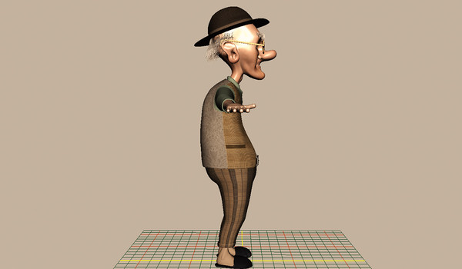

Tools such as:

* pulse sensors to measure pulse rates to a fraction of a second
* wireless infrared heat sensors to accurately measure heat-flow throughout the body
* perspiration meters
* electromagnetic frequency measuring devices and brain signal processors
* color gradient amplifier
* blood pressure measure

all have been developed significantly and are all easily acquirable. In addition to these tools, the X-box Kinect allows for accurate wireless motion detection in one dimensional frame with an open source API at our disposal.

In our group we wish to develop software that would compile and process data collected through these devices to accurately reflect the bodily functions taking place in terms of the musculoskeletal system as the user conducts various motions. In compiling this data we will be able to present a clear, intuitive, user friendly rendering of the users’ physiology, allowing them to see:

* If they are performing the correct motion
* If they are applying tension to the correct parts of the body
* If there is unnecessary tension being applied to the wrong parts of the body
* Which form of movement would provide the least stress to already-injured areas of the body in the real time.

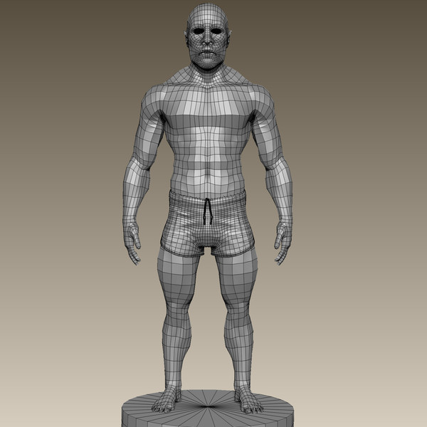

In the case of runners, 27-70% of runners both recreational and competitive expect to be injured during any 1-year period. [11] This data alone expresses the severity of physical activity injuries in human beings as a whole. While athletes are more prone to injuries due to the increased intensity of their movements, non-athletes are more susceptible due to their general lack of high intensity exercises. This means that their muscles are less flexible, and their joints are less able adapted to counteract this stress.[12] While retrospective treatment of injuries may assist the patients to heal following an overuse injury, prevention would be preferable[11]. "A proactive approach could take any forms such as education of... proper fitting and selection of shoes (in the case of runners) and a screening process whereby medical practitioners could identify who are at high risk for overuse injuries and advise accordingly"[11]. VirtueX can help with both of the and go even further. Not only can it allow medical practitioner to identify, but it will enable users at home to easily interpret motions that are causing stress and therefore adjust accordingly.

Furthermore, it has been difficult for many people to learn the correct way to exercise specific muscles so as to avoid injury or enhance recovery because this has always been done with the naked eye. Many times weight rooms merely provide pictures of how to correctly use machines or other exercise tools. But these are generic and do not ensure the *most* efficient muscle movements. Other times physical therapists can give feedback in real time, but this is based only on what they are able to observe visually. Our design adds an extra dimension where users are able to easily see their internal body processes through our multiple data measure and a simple, intuitive GUI which will in turn allow for accurate and optimized understanding of body motion effects thereby eliminating human error on both sides of the injury-recovery process.

**2 System**

We propose to develop software to compile and process data from the following input devices into a practical GUI to give accurate, real-time feedback to the user, optimizing his or her muscle movements:

* Xbox Kinect *2
* pulse sensors to measure pulse rates to a fraction of a second
* wireless infrared heat sensors to accurately measure heat-flow throughout the body
* perspiration meters
* iSET: color gradient amplifier
* blood pressure measure

Our first steps would be need finding related. We will want to:

* Conduct surveys:
  + Of physiotherapy patients: Survey has been created and we will be giving it to physical therapists in both University Health Center, athletic trainers and other out of school therapists
  + Regular healthy adults (18+): Survey has been completed and has been given out.
  + Healthy athletes: Survey completed distributing to trainers on varsity teams to give to athletes.
  + Injured athletes: same as above
  + Old people
  + Doctors/ researchers/ professionals(* please refer to end of paper)
* Conduct interviews:
  + Mostly with specialists to get more information: we have been in touch and will be proceeding to meet in the following days
* Research:
  + Find out already existing devices like these:

-None have been found

* + Possible tools available to us

-X-Box Kinect is a major tool

* + What other factors may end up white noising our results: this will mostly be determined during our prototyping and iterations however some examples would be the overall rise in body temperature when conducting a certain exercise. This however is a problem that we have already determine d a solution to-- during our low fidelity prototyping based on the subjects body mass index, body fat percent and perspiration rate we can determine the expected rise in overall body temperature vs. the rise in the temperature of the certain part of the body being worked out. When an individual is actually using the device in a higher fidelity prototype we will standardize this temperature and write an algorithm to subtract the temperatures throughout the body so as the only focus on the temperature rise in the part of the body being worked out.

After we have analyzed our results, we will want to start our prototyping process:

* + *Low fidelity: Disparate data collection devices:*
  + **X-box kinect:** We will want a subject to do different static motions in from of the Kinect. This will allow us to calibrate, understand and normalize how the Kinect interprets various movements. We can then hardwire this information into a software application using either java for data analysis.

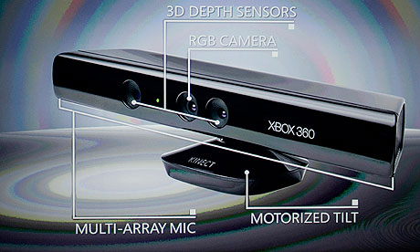

* + With the Kinect alone we can collect data using the : 3-D depth sensors, RGB camera and the motorized tilt to analyze the movements.
  + One known weakness however of the X-box is limitation in that it can only interpret images in the (x,y) planar field. We would like to tackle this problem by taking two kinects and placing their normal points perpendicular to each other: (PTO)
    - This will allow us to get a depth measure of the user’s motions in a 3D plane giving us greater accuracy using the Cartesian distance.
* Infrared: we would require the user to perform various movements in front of the infrared heat sensor. This would be the calibration process that allows us to standardize the heat distribution throughout the body so that we would take increased note of the rise in heat of the targeted part of the body. (however from our research of the Kinect we have been led to believe that an infrared has been inbuilt into the Kinect)

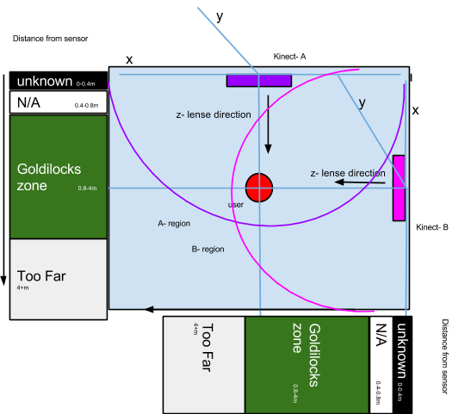

* Pulse meter and blood pressure: we would do the same for these as well
* pixel gradient: Allows for an additional dimensional element by increasing the fractional increase in pixel hexadecimal value we can generate a range of conclusions that conventional devices cannot from blood flow to muscle contraction/ muscle tension.

We know that certain physiological changes take place when a muscle is being exercised. The activated muscles (relative to the rest of the body) will experience increased blood flow, a peak in pulse rate, increased perspiration to the surface of the skin, thousands of electrical nerve impulses directed in the direction of the muscles, and increased heat flow. Our proposed system will present a clear, intuitive, user-friendly rendering of the users’ physiology showing them:

* If they are performing the correct motion
* If they are applying tension to the correct parts of the body
* If there is unnecessary tension being applied to the wrong parts of the body
* Which form of movement would provide the least stress to already-injured areas of the body in the real time.

Our project requires both hardware and software processes:

***1) User plugged into Kinect, other available devices***

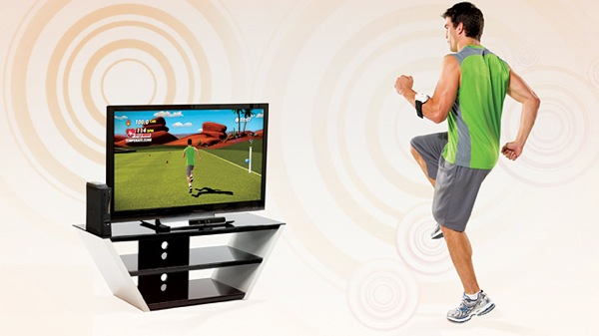

***2) Back end development:***

* MySQL to store and process data;
* Java / Python for data processing:
  + Data cleaning:
    - Fin missing values
    - Fix noisy data
  + Data integration :
    - Correlation and redundancy analysis
  + Data Reduction:
    - Wavelet Transformation
    - Principal Component analysis
    - etc
* Data Similarity and dissimilarity measures
* Data transformation and Discretization:
  + Normalization
  + Binning/ histogram analysis
  + Cluster analysis

**3) Data visualization using JavaScript**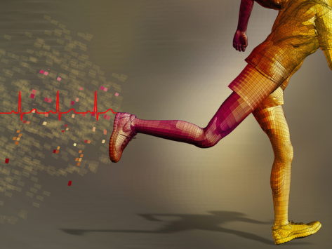

**4) Finally UI development using various web features, java applets, mobile devices and JASK**

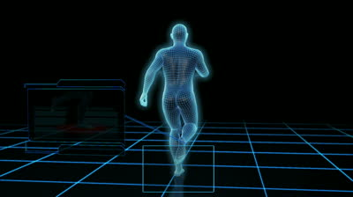

With our project, we will through major data analysis determine with great accuracy the areas of the body going through muscular activation. In this way we can reveal to the user a new dimension of their body that they could never see with the naked eye. Our device will be able to help people ranging from regular people with their everyday interaction, to athletes with their high performance movements to injured individuals in preventing them from further causing stress to the injured parts of their bodies.

**Detailed technical plan:**

1. Acquire devices ( the more the better-- more data more accuracy) -- low fidelity
2. Figure out how to use devices
3. Make individual use one device at a time: so that we can see how data is received.
4. Create database to store data (mySql)
5. Make individual use device again and collect data this time recorded over time -- 2nd low fidelity iteration
6. Analyze data; normalized, and do various data processing (Java/ python)
7. Data visualization using this processed data (JavaScript)
8. Transfer data into UI form (Web and java applets)
9. Make individual use device again but with multiple device at same time -- 3rd higher fidelity iteration
10. Data collection
11. Data processing
12. Data visualization
13. UI
14. Try to implement a Real- time feature; i.e. link steps 1 (device usage), 2 (data collection), 3 (data processing), 4 (data visualization), and 5(UI) all together.
15. Work towards finished product, i.e. make it portable, or such that user does not have to have wires attached to him/her.

**3)Evaluation:**

Using need-finding tools outlined in class we will be able to learn how users can most benefit from this technology. Though our system will have broad implementation possibilities, it will be most beneficial to gather data from frequent-users (athletes) and muscle-use experts (physical therapists). Both surveys and in-depth interviews of these demographics will be of use in creating our first hi-fi prototype, and subsequent feedback will guide our further design iterations.

**Act:** Come up with a skit that presents the context of your project to the class. See the video below (also located here) for an example.

Our skit could easily take the form of either a student’s visit with a physical therapist who utilizes our system or a weight room junkie using our technology to enhance his personal workout routine. We could have the user hook up to the system in real time and project the interface to the class. The user could begin by purposefully using a muscle incorrectly and slowly correct his or her motion using the feedback.

**Team Recycle- VirtueX**

**Rikesh Thapa:**

* Major: Computer Science (BS) Financial Economics (BA)
* Year: 2015
* Programming language: C, JAVA, Python, MatLab, STATA, (HTML5); JAVAScript, HTML, CSS, SQL, PHP, DOM, AJAX,
* Expertise (more experience in rather than expertise): Data related/ Big Data analysis; Front end Web design and UI design, Back end coding
* Weakness: Graphic design
* Preference for topic: The topic we are doing now/ Open to any other ideas.

**Cara Kessler**

* Major: Computer Science (BS)
* Year: 2015
* Programming language: C, Java, Python, HTML5, JAVAScript, CSS, SQL, AngularJS, AJAX, jQuery
* Expertise: Front end web design and most Javascript frameworks. I also have knowledge of and experience with Adobe products such as Photoshop and Flash
* Weakness: Data analytics
* Preference for topic: The topic we are doing now

**Charlie Henick:**

* Major: Financial Economics (BA)
* Year: 2014
* Programming language: JAVA, Python, STATA, HTML5, CSS
* Expertise: Data analytics
* Weakness: Coding, all knowledge of programming languages is basic
* Preference for topic: The topic we are doing now

**Adam Cushmaro**

* Major: Computer Science (BA)
* Year: 2015
* Programming language: C, Java, Python, HTML5, JAVAScript, CSS, SQL, AJAX, jQuery
* Expertise: Web design and backend frameworks and database design
* Weakness: Data analytics
* Preference for topic: The topic we are doing now

**Christopher Wong:**

* Major: Computer Science (BS)
* Year: 2016
* Programming language: C, Java, Python
* Expertise: Design, Some programming knowledge (Material from CSC 171-173)
* Weakness: Web programming, Statistics
* Preference for topic: This topic, but open to other ideas.

**Lukas Slipski:**

* Major: Health, Behavior, and Society
* Take 5: Big Data and HCI
* Year: 2014
* Programming Language: Java
* Expertise: Ethnography, some survey design and analysis, writing
* Weaknesses: I have only been programming for 1.5 semesters
* Preference: I’m really excited about our current proposal

**Marquis Massie**

* Major: Brain & Cognitive Sciences
* Year: 2015
* Programming Language: Java
* Expertise: Partial survey analysis
* Weakness: Basic knowledge of programming
* Preference for Topic: This topic

**References**

[1]<http://www.pitt.edu/~epi2670/injuryhistory/History2009.pdf>

[2]<http://weill.cornell.edu/archives/pdf/personal_aids/DeHaven.pdf>

[3]<http://www.pitt.edu/~epi2670/tenet/TenPrinciples.pdf>

[4]<http://www.painmed.org/patientcenter/facts_on_pain.aspx>

[5]<http://www.cbsnews.com/2100-201_162-5205668.html>

[6]<http://www.stopsportsinjuries.org/resources/coaches-curriculum-toolkit/overuse-injuries.aspx>

[8]<http://www.childrenshospitalofillinois.org/pdfs/different/2-Sports-and-Rec-Fact-Sheet-2013.pdf>

[7]<https://www.sportsmed.org/uploadedFiles/Content/Medical_Professionals/Professional_Educational_Resources/Publications_and_Resources/Sports_Medicine_Update/SMU_2009/SMU%20Mar%20Apr%2009.pdf>

[8]<http://www.ncbi.nlm.nih.gov/pubmed/16558577>

[9]<https://www.osha.gov/dts/osta/otm/otm_vii/otm_vii_1.html>

[10]<http://www.thedoctorwillseeyounow.com/content/aging/art2075.html?getPage=2>

[11]<http://www.med.nyu.edu/pmr/residency/resources/Clinics_sports%20med/runner%20overuse%20injuries_PMR%20clinics.pdf>

[12]<http://www.ncbi.nlm.nih.gov/pmc/articles/PMC3445246/?tool=pmcentrez&rendertype=abstract>

**\*Specialist List Reference**

Dr. Martha Eastlack:

* Assistant Professor of Physical Therapy
* [eastlacm@arcadia.edu](mailto:eastlacm@arcadia.edu)

David M. Selkowitz

* Professor at the college of Allied Health Professions department of Physical Therapy Education
* PhD, Kinesiology, The Union Institute, Cincinnati, OH, 2001
* MS, Physical Therapy, Boston University, Boston, MA, 1982
* BA, Anthropology, State University of New York at Buffalo, Buffalo, NY, 1978
* contact: (909)-469-5251

Dr. Roger M. Enoka

* Professor at the University of Buffalo department of Integrative Physiology
* email: enoka@colorado.edu